**CMPS115 Sprint 2 Plan**

**Goal**

After the second sprint, it should be possible for administrators to remove bad content and for readers to be able to use the app on shaky connections. Readers will also be given various quality-of-life improvements.

**Task Listing**

**User Story 1** - As a reader, I would like to be able to search for specific comics so that I can

easily find content that interests me.

* Build angular search service (2 hrs)
* Add search UI to comic list (4 hrs)

*Total Time - 6 hrs*

**User Story 2** - As a reader, I would like to be able to return to the last page I read so that I can

easily pick up where I left off.

* Store read pages in IndexedDB (3 hrs)
* Write logic to skip to latest page of logical section (whole comic or chapter) (2 hrs)
* Modify UI with skip buttons for comic/chapter (2 hrs)

*Total Time - 7 hrs*

**User Story 3** - As a reader, I want the viewing experience to be smooth, even when my

connection is poor, so that I can read the comics with greater ease.

* Preload images next few pages (2 hrs)
* Store previous comic metadata/comic list then merge with new results from server (5 hrs)
* Add PWA Manifest (2 hrs)
* Ensure Service Worker installs correctly (3 hrs)

*Total Time - 12 hrs*

**User Story 4** - As an administrator, I want to be able to remove inappropriate content so that I can

maintain the integrity of the web comic viewer.

* Make backend separate user/admin role in the database (1 hr)
* Create backend route to delete a comic ( 3 hrs)
* Create UI for admins to delete a comic ( 3 hrs)

*Total Time - 7 hrs*

**User Story 5** - As an administrator, I want to be able to ban problematic account users so that I

can prevent repeat offenses from occuring.

* Make a attribute in the user table to mark a banned account (1 hr)
* Prevent users from logging in to banned accounts and rescind their authorization (tokens should be invalid) (3 hr)
* Create a route that marks an account banned (3 hrs)
* Build UI for an admin to ban a comics owner (3 hrs)

*Total Time - 10 hrs*

**User Story 6** - As an administrator, I want to be able to communicate issues with account

users so that they understand what violations they made.

* Create a table to store admin messages. (2 hrs)
* Create a route where admins can send messages. (3 hrs)
* Create a route where users can look up messages received. (3 hrs)
* Create UI for admins to send messages to users. (3 hrs)
* Create UI for users to receive messages. (3 hrs)

*Total Time - 14 hrs*

**Team Roles**

Will: Product Owner, Full-stack Dev

Myron: Backend Dev

Sammy: Backend Dev

James: Frontend Dev

Mehtab: Scrum Master, Backend Dev

Alan: Scrum Master, Full-stack Dev

**Initial Task Assignment**

Will: User story 3 - Add PWA Manifest (2 hrs)

Myron: User story 5 - Make a attribute in the user table to mark a banned account (1 hr)

Sammy: User story 4 - Create a backend route to delete comics (3 hrs)

James: User story 1 - Add search UI to comic list (4 hrs)

Mehtab: User story 1 - build Angular search service (2 hrs)

Alan: User story 2 - Store read pages in IndexedDB (3 hrs)

**Initial Burnup Chart**

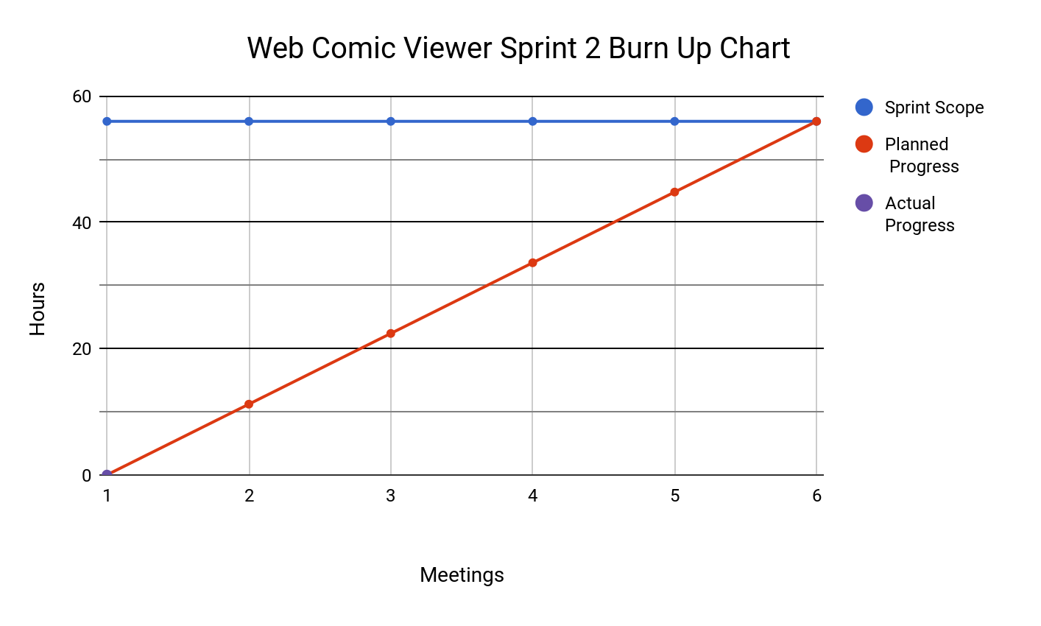

# Scrum Times

Monday: 4:00-4:15

Tuesday: 4:10-4:25 - TA meeting

Thursday: 3:30-3:45